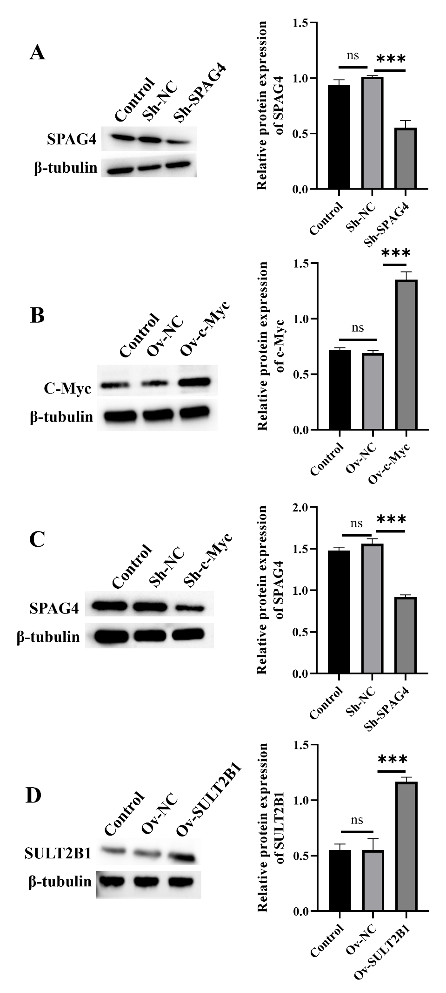
Figure S1. Efficiency verification of silencing and overexpressing genes.
(A) A Western Blot was used to verify the efficiency of SPAG4 silencing.
(B) A Western Blot was used to verify the efficiency of c-Myc overexpression.
(C) A Western Blot was used to verify the efficiency of c-Myc silencing.
(D) A Western Blot was used to verify the efficiency of SULT2B1 overexpression.

